Secondary Science Adopted Resources - 2023-2024

Middle School
Course | Textbook | Publisher | Format | Image
6th Science | Science Gizmos | ExploreLearning | Online | 
7th Science | Science Gizmos | ExploreLearning | Online
8th Science | CPO Science | CPO Science | Print with digital access | 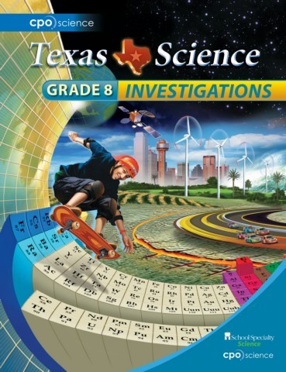
8th Science | Science Gizmos | ExploreLearning | Online

High School
Course | Textbook | Publisher | Format | Image
Biology  IH Biology | Texas Biology | Houghton Mifflin Harcourt (HMH) | Print with digital access | 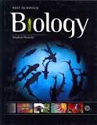
Chemistry | Texas Modern Chemistry | Houghton Mifflin Harcourt (HMH) | Print with digital access | 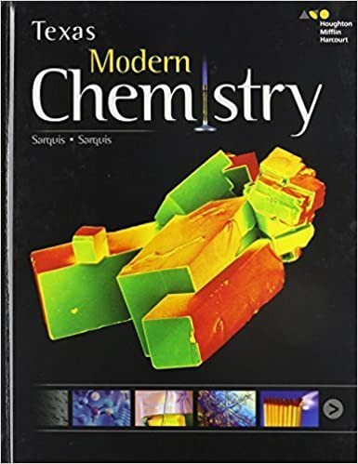
Integrated Physics and Chemistry  (IPC) | CPO Science  (Curiosity Place) | CPO Science | Print with digital access | 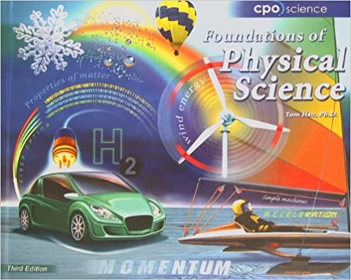

Senior High School
Course | Textbook | Publisher | Format | Image
Anatomy & Physiology | Hole’s Essentials of Human Anatomy & Physiology  (12th ed) | McGraw-Hill  School Education LLC | Print with digital access | 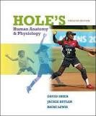
Earth and Space Science | Earth Science (8th ed) | Prentice Hall | Print | 
Environmental Systems | How the World  Works and Your  Place In It  (3rd ed) | J M Lebel Enterprises Ltd | Print | 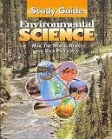
Physics | Physics Principles & Problems | McGraw-Hill  School Education LLC | Print (class set) with digital access | 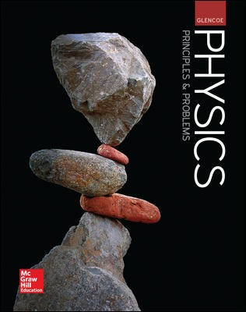

Advanced Placement
Course | Textbook | Publisher | Format | Image
AP Biology | Campbell Biology (12th ed) | Pearson | Print | 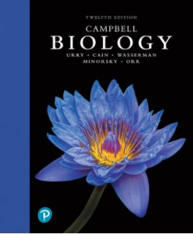
AP Chemistry | Chemistry (AP) (9th ed) | Cengage Learning | Print | 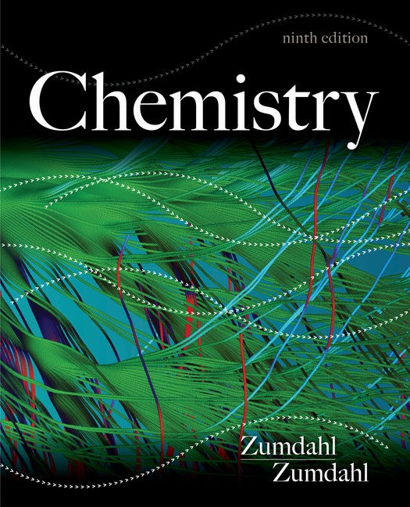
AP Environmental Systems | Environmental  Science for the  AP Course  (4th ed) | BFW Publishing | Online | 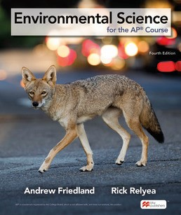
AP Physics 1-2 | OpenStax | Rice University | Online | 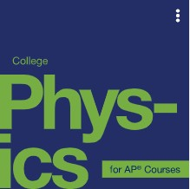
AP Physics C | OpenStax | Rice University | Online

IB Program
Course | Textbook | Publisher | Format | Image
IB Biology | IB Biology | Oxford University Press | Print | 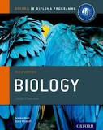
IB Biology | Campbell Biology (12th ed) | Pearson | Print
IB Chemistry | IB Chemistry | Oxford University Press | Print | 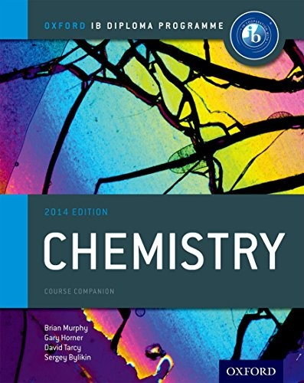
IB Chemistry | Chemistry (AP) (9th ed) | Cengage Learning | Print
IB Environmental Systems | IB Environmental  Systems & Societies | Oxford University Press | Print | 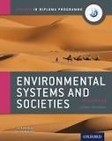
IB Physics | IB Physics | Oxford University Press | Print | 